3. Adjusting Entries: 2. Reverse Cash Receipt on a Deposit

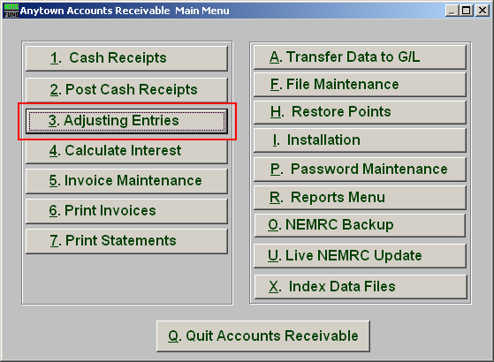
Click on “3. Adjusting Entries” from the Main Menu and the following window will appear:

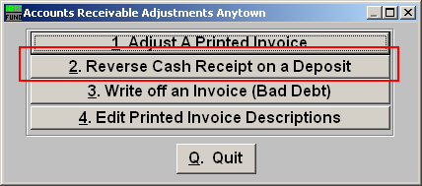
Click on “2. Reverse Cash Receipt on a Deposit” from the Adjusting Entries Menu and the following window will appear:
Reverse Cash Receipt on a Deposit

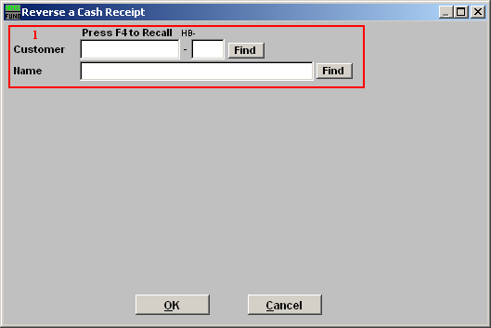
- Find: Enter the Customer number or Name or click “Find” and locate the Customer from the list.

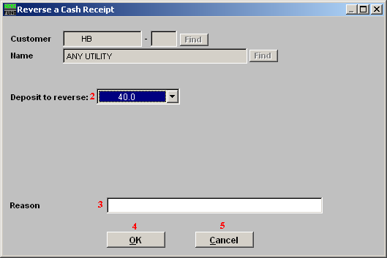
- Deposit to reverse: Type in the Deposit to be reversed or click on the drop down arrow and select from there.

- Reason: Type in the Reason for reversing the Deposit.

- OK: Click “OK” to have the system reverse the application of cash on that deposit for the selected customer account.

- Cancel: Click “Cancel” to cancel and return to the previous screen.

